**SALESFORCE PROJECT READY**

**ENTRY LEVEL TRAINING PROGRAM:**

**Day 1 :**

**Topic:**

Account Creation on Salesforce

**Milestone / Activities:**

Account Created, Org created

**Detailed Description:**

Account and org created for salesforce

**Upload the Screenshot the Milestone / Activities :**

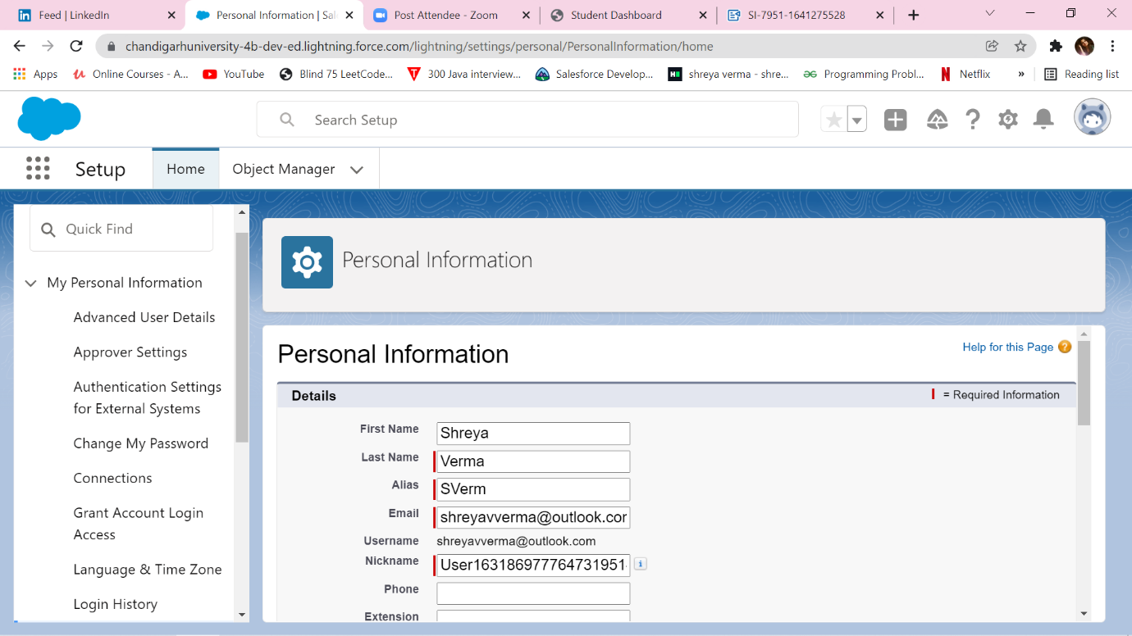

**Day 2 :**

**Topic:**

Setting Up First App, Custom Object and Fields Creation

**Milestone / Activities:**

Make a custom application, Add Object and Feilds

**Detailed Description:**

Task is to create a custom salesforce application, Create and Add Custom objects to it.

App Created - College Management

Objects Created are -

1. College

2. Application Form.

3. Students.

4. Subjects.

Feilds Created on these custom objects.

College-

|  |  |  |  |
| --- | --- | --- | --- |
| Field Name | Data Type | Required | Values |
| Record Info | Text |  |  |
| College Fees | Currency(7,2) | Yes |  |
| Hostel Fees | Currency(6,2) | Yes |  |
| College Name | Picklist(Refer Business Logic In Milestones) | Yes |  |
| Email | Picklist |  | blr@mit.co.in  hyd@mit.co.in  mum@mit.co.in  maa@mit.co.in  ccu@mit.co.in  del@mit.co.in |
| Capacity Of Students | Picklist |  | 500-1000, 1000-2500, 2500-6000, 6000-10000 |

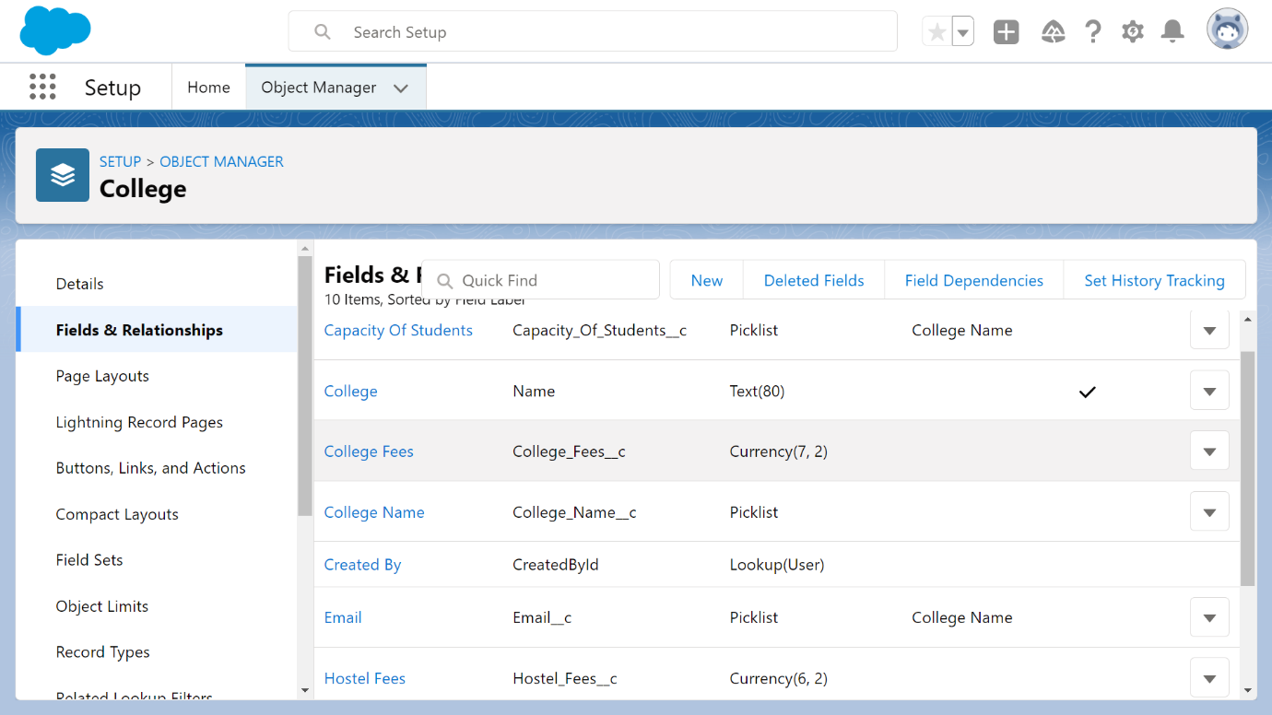

**Fields On Application Form Object**

|  |  |  |  |
| --- | --- | --- | --- |
| Field Name | Data Type | Required | Values |
| Application Form ID | Autonumber |  | F-{000000}  Starting Number=1 |
| Address | Text(255) | Yes |  |
| College | Master-Detail(College) | Yes |  |
| College Fees | Formula(Currency) |  |  |
| Hostel Fees | Formula(Currency) |  |  |
| date of Birth | Date | Yes |  |
| Email | Email(Unique) | Yes |  |
| Guardian Name | Text(30) | Yes |  |
| Looking For Hostel Stay | Checkbox(default=Uncheck) |  |  |
| Ready To Join | Checkbox(default=Uncheck) |  |  |
| Student Name | Text(30) | Yes |  |
| Phone | Phone | Yes |  |

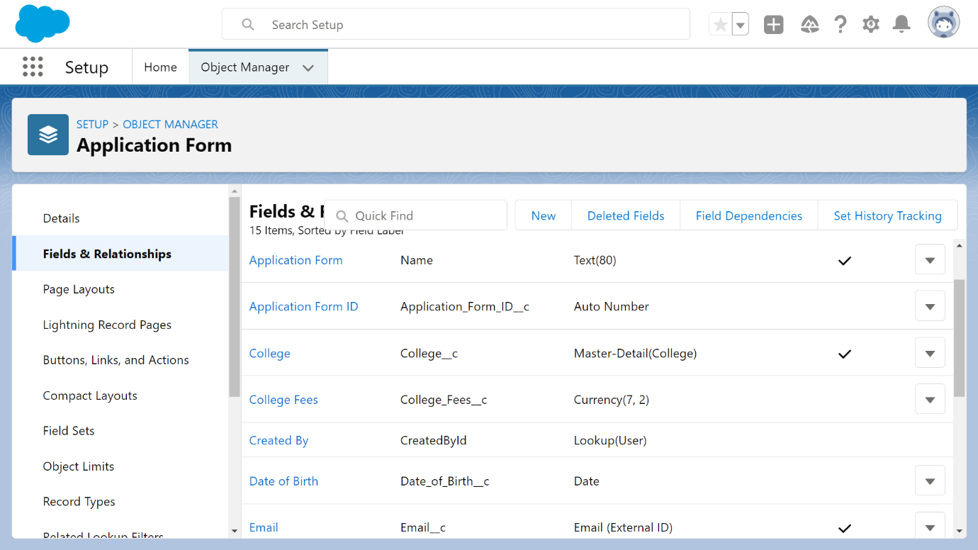

**Day 3 :**

**Topic:** Continuation of Student and Subject Object-

**Milestone / Activities:**

Fields on the student object.

|  |  |  |  |
| --- | --- | --- | --- |
| Field Name | Data Type | Required | Values |
| Student Name | Text |  |  |
| Address | Text(255) | Yes |  |
| Application Form | Lookup(Application Form) |  |  |
| College Name | Formula(Text) |  |  |
| Date Of Birth | Date | Yes |  |
| Guardian Name | Text(30) | Yes |  |
| Phone | Phone | Yes |  |

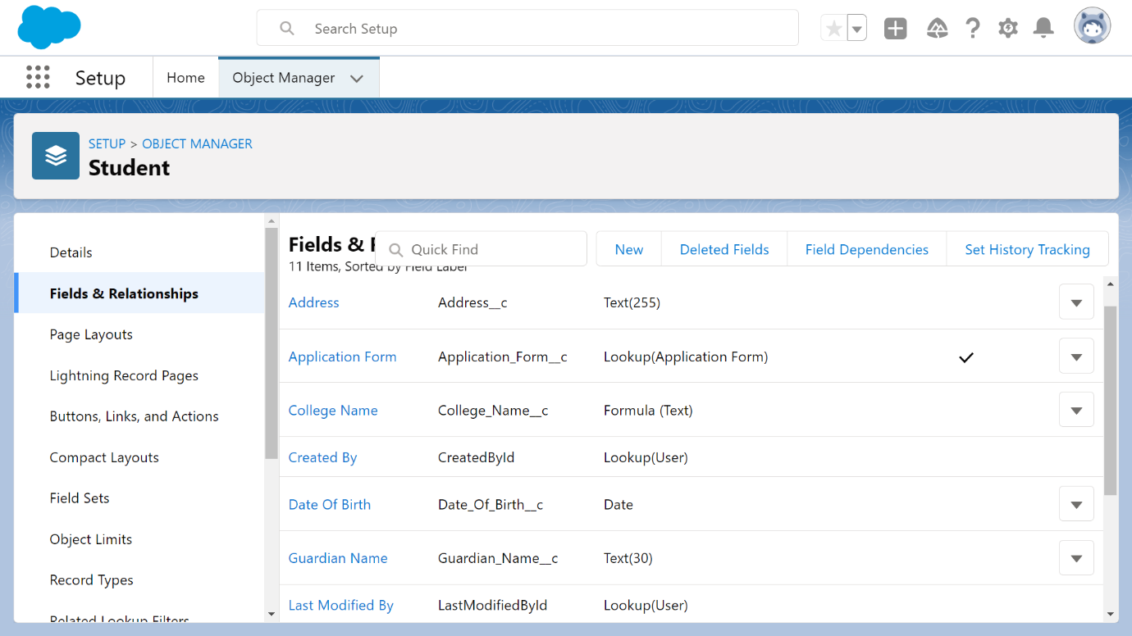

Fields On the Subject object.

|  |  |  |  |
| --- | --- | --- | --- |
| Field Name | Data Type | Required | Values |
| Subject ID | AutoNumber |  | S-{000000}  Starting Number=1 |
| Paper 1 | Picklist(Refer Business Logic Milestone) |  |  |
| Paper2 | Picklist(Refer Business logic Milestone) |  |  |
| Student | Lookup(Student) |  |  |

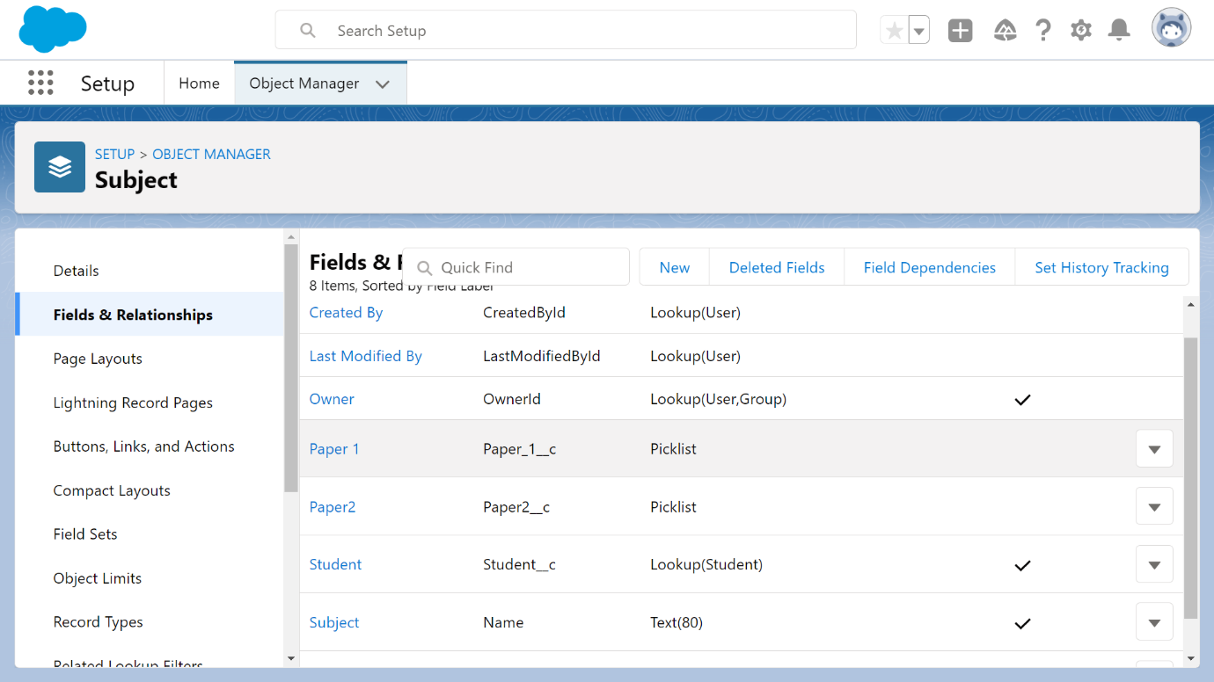

Upload the Screenshot the Milestone / Activities :

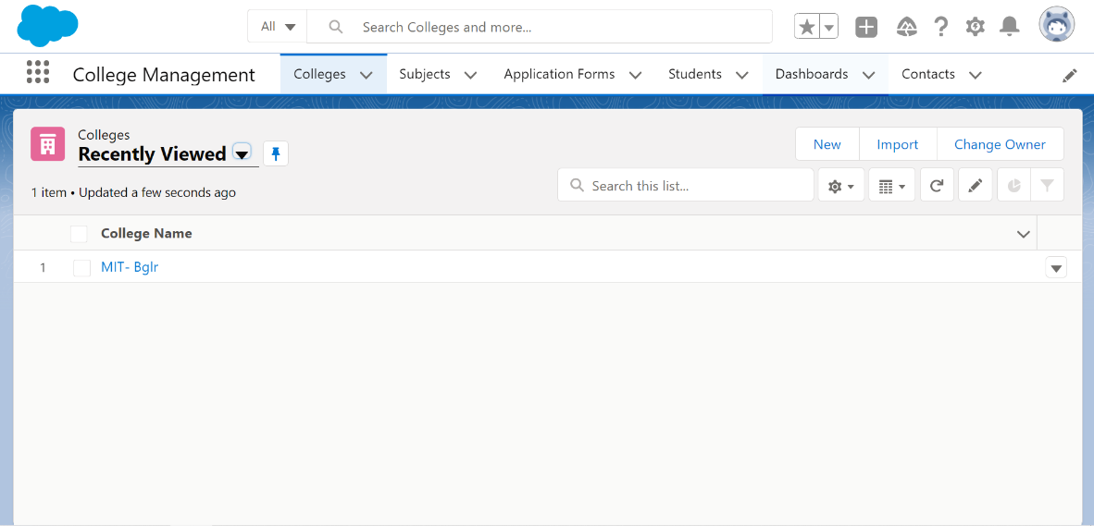

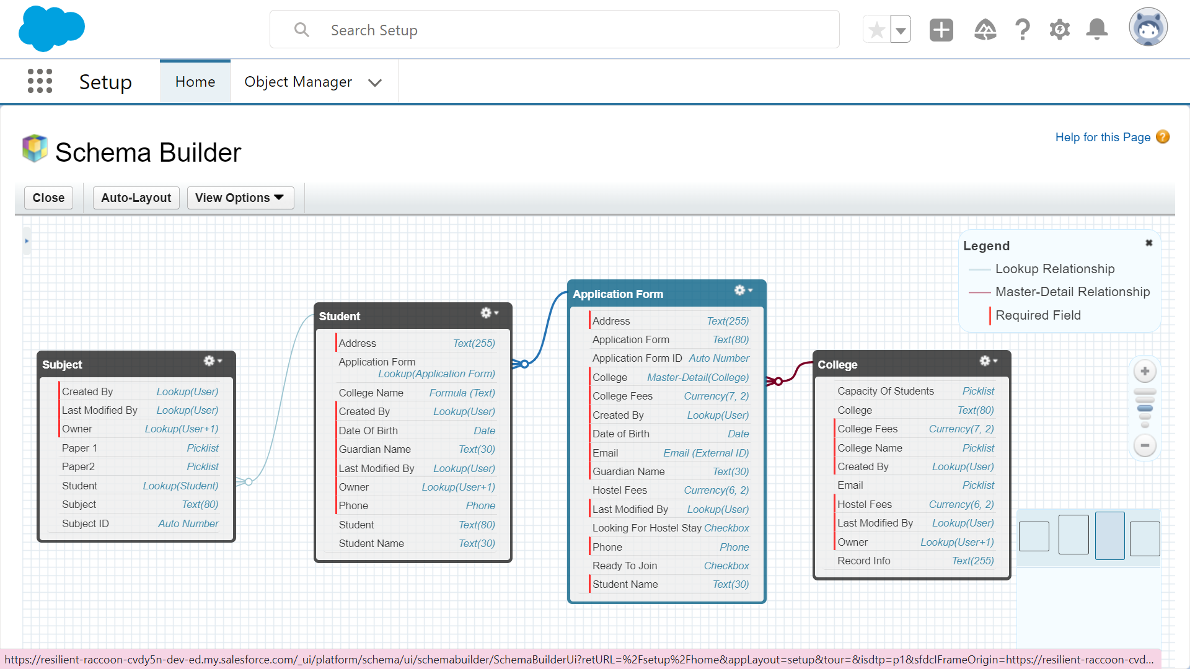

Day 4 :

Topic: Milestone / Activities:

Detailed Description:

Upload the Screenshot the Milestone / Activities :

Day 5 :

Topic: Milestone / Activities:

Detailed Description:

Upload the Screenshot the Milestone / Activities :

Day 6 :

Topic: Milestone / Activities:

Detailed Description:

Upload the Screenshot the Milestone / Activities :